Manil Singha Malla

wcrecent@gmail.com

AI Lab 1

2018/02/26

1. Write a prolog program to find factorial of given numbers.

* Code:-

PREDICATES

fact(integer,integer)

CLAUSES

fact(X,F):- X=0,F=1.

fact(X,F):- X<>0,T=X-1,fact(T,F1),F=X\*F1.

GOAL

fact(5,F).

* Output:-

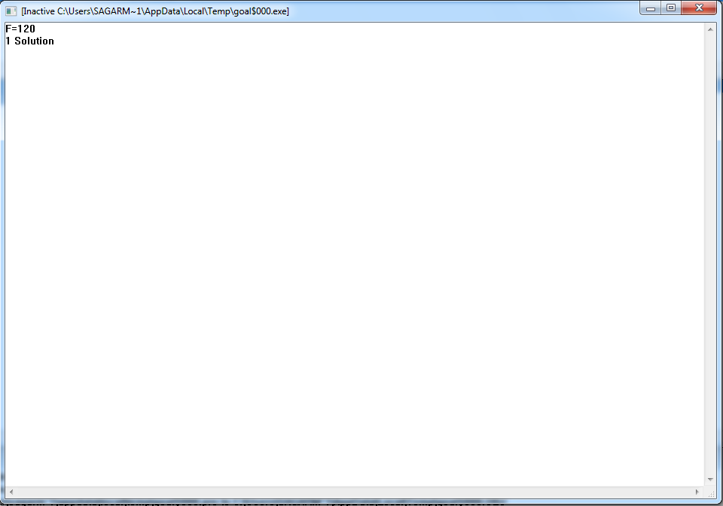



1. Write a prolog program to find length of given list.

* Code:-

DOMAINS

list = integer\*

PREDICATES

length(list,integer)

CLAUSES

length([],0).

length([H|T],L):-length(T,L1),L=L1+1.

GOAL

length([2,4,6,8],L).

* Output:-



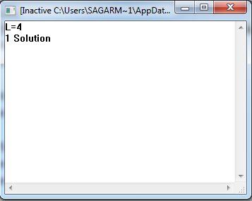

1. Write a prolog program to find minimum of two numbers.

* Code:-

PREDICATES

min(integer,integer,integer)

CLAUSES

min(A,B,M):-A>B,M=B.

min(A,B,M):-A<B,M=A.

GOAL

min(7,5,M).

* Output:-

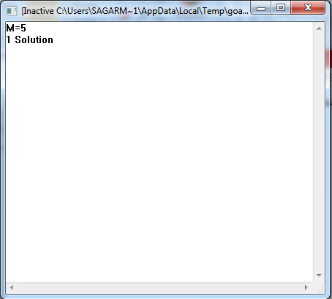

Note :-

* All variables must be CAPITALISED.
* Use Visual Prolog (i.e. VIP).